**Query for Problem:**

|  |
| --- |
| INSERT INTO LOCATION (LOCNO, FACNO, LOCNAME)  VALUES (‘L108’,’F104’,’Locker Room’); |

**Snapshot for the Problem:**

1. **Before inserting**

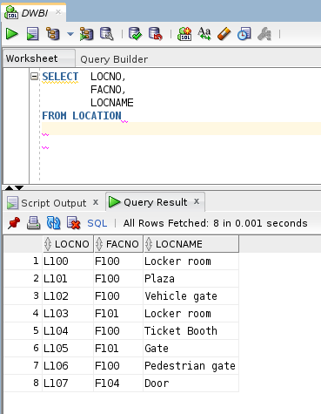

1. **Executing the insert query**

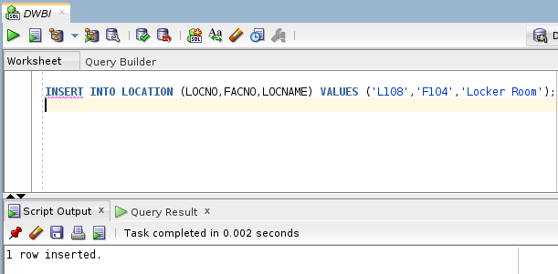

1. **After executing**